Name: BAO, Qingjun

ID Number: 2398022

Date: 2023/05/19

This tutorial is from w3.org covering HTML basics. Read through this document and use copy and paste for the “Try It” and “Challenge” sections.

https://www.w3.org/community/webed/wiki/HTML/Training

Contents:

* What is HTML?

**HTML** is a **HyperText Markup Language** for creating Web pages. It is used to create Web pages. That is, Web pages all over the world consist of HTML.

**HTML5** is a markup language used for structuring and presenting content on the World Wide Web. It is the fifth and final major HTML version that is a World Wide Web Consortium (W3C) recommendation. The current specification is known as the HTML Living Standard. It is maintained by the Web Hypertext Application Technology Working Group (WHATWG), a consortium of the major browser vendors (Apple, Google, Mozilla, and Microsoft).

<https://en.wikipedia.org/wiki/HTML5>

* Tag syntax

HTML is using tags for its syntax. A tag is composed with special characters: <, > and /. They are interpreted by softwares to compose an HTML element. HTML elements usually come in tag pairs.

For opening a simple element with a start tag

it starts with <

then a list of characters without space, the tag name (or element)

ends usually with a >.

Then closing the simple element with an end tag

it starts with </

then the same list of characters without space, the tag name (or element)

ends usually with a >.

* Create HTML

We can write HTML by hand using a basic text editor such as Notepad on Windows, TextEdit on MacOS, gedit on Ubuntu Linux, etc. However we should save a page in the UTF-8 encoding

Web developers often use HTML editors:

Adobe Dreamweaver

Microsoft FrontPage or Expression Web

VSCode

* The HTML Document

The following example is a basic HTML document:

<!doctype html>

<html lang="en">

<head>

Document metadata

</head>

<body>

Document contents

</body>

</html>

**doctype**

The DOCTYPE must be specified, and be top in the HTML document. That is, the DOCTYPE exists before the <html> start tag.

The DOCTYPE declaration is <!DOCTYPE html> and is case-insensitive in the HTML syntax.

<!DOCTYPE html>

or

<!doctype html>

* Metadata
* Basic content
* Hyperlinks
* Link options
* Image

What is HTML

HTML is a Markup Language for creating Web pages.

Description

HTML stands for **HyperText Markup Language**. It is used to create Web pages. That is, Web pages all over the world consist of HTML.  
We can look at how other people have coded their Web pages. Click on the "View" menu and then on "Source".

<!doctype html>

<html lang="en">

<head>

<title>Sample Web page</title>

</head>

<body>

<p>Here is a paragraph</p>

</body>

History

The HyperText Markup Language (HTML) is the publishing language of the World Wide Web. The first version of HTML was described by Tim Berners-Lee in late 1991. For its first five years (1990-1995), HTML went through a number of revisions and experienced a number of extensions, primarily hosted first at CERN, and then at the IETF.

With the creation of the W3C, HTML's development changed venue again. A first abortive attempt at extending HTML in 1995 known as HTML 3.0 then made way to a more pragmatic approach known as HTML 3.2, which was completed in 1997. HTML4 followed, reaching completion in 1998.

|  |  |
| --- | --- |
| **Version** | **Published year** |
| HTML+ | 1993 |
| HTML2.0 | 1995 |
| HTML3.2 | 1997 |
| HTML4.01 | 1999 |

Tag

HTML uses markup tags to create Web pages. All content on the Web page is meant by tag. For examples, "Here is a paragraph", "This is a image" and so on.

Tag syntax

HTML is using tags for its syntax. A tag is composed with special characters: **<**, **>** and **/**. They are interpreted by softwares to compose an HTML element.

Decomposition of HTML elements

HTML elements usually come in tag pairs.

[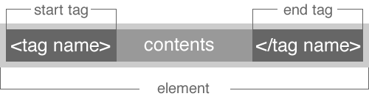](https://www.w3.org/community/webed/wiki/File:Elements.png)

For opening a simple element with a **start tag**

1. it starts with **<**
2. then a list of characters without space, the tagname (or element)
3. ends usually with a **>**.

Then closing the simple element with an **end tag**

1. it starts with **</**
2. then the **same** list of characters without space, the tagname (or element)
3. ends usually with a **>**.

If the tagname is "cite", then you get

<cite></cite>

Some elements do not have an end tag (because they are implied by the following tags). For example you might have seen:

<br>

An element can have attributes to refine its meaning.

[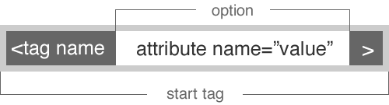](https://www.w3.org/community/webed/wiki/File:Option.png)

These attributes are specified on the start tag. They consist of a name and a value, separated by an "=" character. Such as:

<tagname attribute="value"></tagname>

In HTML, the attribute value can remain unquoted if it doesn't contain spaces or any of the following characters: " ' ` = < or >. Otherwise, it has to be quoted using either single or double quotes. The value, along with the "=" character, can be omitted altogether if the value is the empty string. Once you are working in a team you might want to choose a common way of authoring your code.

These are examples of syntaxes you might see on the Web:

<!-- empty attributes -->

<input disabled>

<input disabled="">

<input disabled=""/>

<!-- attributes with a value -->

<input name=address>

<input name='address'>

<input name="address">

Create HTML

Edit tools

You don't need a special tool for making HTML. We can write HTML by hand using a basic text editor such as Notepad on Windows, TextEdit on MacOS, gedit on Ubuntu Linux, etc. However you should choose an editor that allows you to save a page in the UTF-8 encoding (see more details below).

Web developers often use HTML editors:

* Adobe Dreamweaver

Although the HTML markup of a Web page can be written with any text editor, specialized HTML editors can offer convenience and added functionality. But, I recommend that you use a plain text editor. This is often the best way to learn HTML.

**try it**

Let's make an HTML document.

1. Open **Notepad++** (Windows users) or **TextEdit** (MacOS users).

2. Write the following example.

<!doctype html>

<html lang="en">

<head>

<meta charset="utf-8">

<title>Sample Web page</title>

</head>

<body>

<p>Hello!</p>

</body>

</html>

*Note: Don't worry. You will learn the about these tags in the next chapter.*

Saving the file

**File names**

File name's rules are as follows:

* use either the ".htm" or the ".html" file extension.
* use only alphabets, numbers, "-" (hyphen), and "_" (underscore).

Put in the file name. In this example, "index.html".

Web browsers

A Web browser is a software application for viewing Web pages. There are many kinds of Web browsers and each may display Web pages differently:

* Internet Explorer (Microsoft)
* Firefox (Mozilla)
* Chrome (Google)
* Safari (Apple)
* Opera (Opera)

...etc

You should check whether the Web page is correctly made by two or more Web browsers.

**try it**

Let's view your HTML document on the Web browser.

1. Open the Web browser that you like.

2. Drag & Drop the HTML document file to Web browser, or right-click the HTML file and select to open with the Web browser you want.

*Can you view the your HTML document?*

HTML Document

The following example is a basic HTML document:

<!doctype html>

<html lang="en">

<head>

Document metadata

</head>

<body>

Document contents

</body>

</html>

Description

**doctype**

The DOCTYPE must be specified, and be top in the HTML document. That is, the DOCTYPE exists before the <html> start tag.  
The DOCTYPE declaration is <!DOCTYPE html> and is case-insensitive in the HTML syntax.

<!DOCTYPE html>

or

<!doctype html>

**html element**

The html element represents the root of an HTML document.

* The html element should always have a lang attribute. The lang attribute Specifies the primary language for the contents of the element. For example, "en" means "English", "fr" means "French". There are tools available which provide additional help while searching the langage tag, such as [Richard Ishida's Language Subtag Lookup tool](http://rishida.net/utils/subtags/).
* The <html> ... </html> contains a **head** element followed by a **body** element.

<html lang="en">

</html>

**head element**

The head element represents a collection of metadata for the Document.

* The <head> ... </head> contains the title, and information on style sheets and scripts.
* Contents in the head tag are not displayed on a Web browser.

<head>

</head>

**body element**

The body element represents the main content of the document.

* The <body> ... </body> contains the markup with the **visible content**.

<body>

<p>Here is the visible content</p>

</body>

*These tags compose the base of HTML document.*

Metadata

The following example represents the document metadata:

<head>

<meta charset="utf-8">

<title>About W3C | World Wide Web Consortium(W3C)</title>

<meta name="description"

content="The World Wide Web Consortium (W3C) is an international community

where Member organizations, a full-time staff,

and the public work together to develop Web standards.">

<meta name="keywords" content="W3C, HTML, HTML5, XHTML,

CSS, CSS3, SVG, MathML, WCAG">

</head>

character setting

The character encoding used by the document is specified by **the charset attribute** for the meta element.

<meta charset="utf-8">

title

Web page's title is specified by <title>.

* Title is used in a title bar of Web browsers, user's history, bookmarks, or in search results.
* You should use titles that identify their documents even when they are used out of context.

<title>About W3C | World Wide Web Consortium(W3C)</title>

**try it**

Let's create the Web page of the shop of fictitious.  
I create the "W3C cafe".

1. describe the Web page's title between <title> ... </title>.

[Example]

<head>

<meta charset="utf-8">

<title>HOME | W3C cafe</title>

</head>

2. Check the Web browsers.

Web page's description

Web page's description is specified by <meta name="description">.

* You describe the Web page's description in the content attribute.

<meta name="description" content="The World Wide Web Consortium (W3C) is an international community

where Member organizations, a full-time staff, and the public work together to develop Web standards.">

**try it**

1. Describe the Web page's description. [Example]

<head>

<meta charset="utf-8">

<title>About W3C cafe | W3C cafe</title>

<meta name="description" content="The W3C cafe is .....">

</head>

Web page's keywords

Web page's keywords are specified by <meta name="keywords">.

* You describe the Web page's keywords in the content attribute.

<meta name="keywords" content="W3C, HTML, HTML5, XHTML, CSS, CSS3, SVG, MathML, WCAG">

**try it**

1. Describe the Web page's keywords. [Example]

<head>

<meta charset="utf-8">

<title>About W3C cafe | W3C cafe</title>

<meta name="description" content="The W3C cafe is .....">

<meta name="keywords" content="W3C cafe, coffee, .....">

</head>

***Note: The document metadata introduces here is not all.***

Basic content

The following example is a basic content.

<body>

<h1>ABOUT W3C</h1>

<p>The World Wide Web Consortium (W3C) is an international community where Member organizations,

a full-time staff, and the public work together to develop Web standards.</p>

<hr>

<h2>Questions About W3C or the Web?</h2>

<p>Please consult the Help and FAQ for answers to questions such as:</p>

<ul>

<li>What does W3C do?</li>

<li>How is W3C funded?</li>

<li>Is W3C sending me spam?</li>

</ul>

</body>

Heading

Headings are specified by **<h1>, <h2>, <h3>, <h4>, <h5> and <h6>**.

* <h1> is said to have the highest rank, <h6> has the lowest rank, and two elements with the same name have equal rank.

<h1>h1 example</h1>

<h2>h2 example</h2>

<h3>h3 example</h3>

<h4>h4 example</h4>

<h5>h5 example</h5>

<h6>h6 example</h6>

[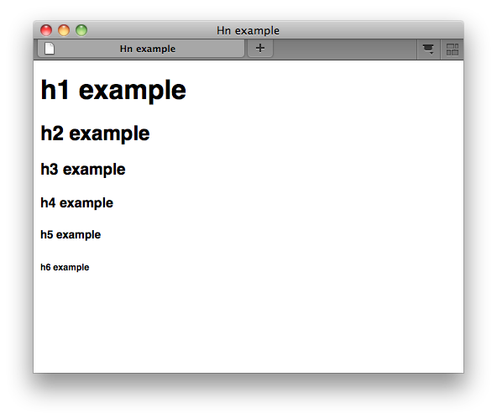](https://www.w3.org/community/webed/wiki/File:Tr_hn01.png)

Paragraph

Paragraphs are specified by **<p>**.

<p>This is paragraph 1</p>

<p>This is paragraph 2</p>

[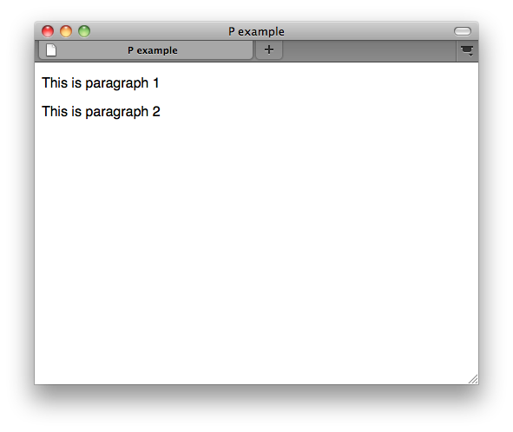](https://www.w3.org/community/webed/wiki/File:Tr_p01.png)

Line

horizontal rules are specified by **<hr>**.

* The hr element can omit end element. This is because It is empty element.

<p>This is paragraph 1</p>

<hr>

<p>This is paragraph 2</p>

[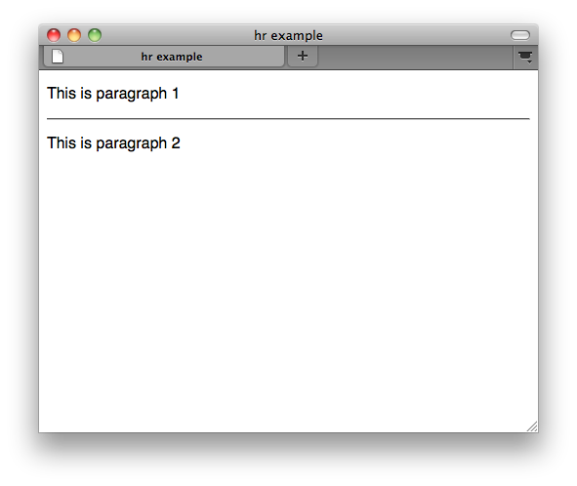](https://www.w3.org/community/webed/wiki/File:Tr_hr01.png)

List

**unordered list**

Unordered list is specified by **<ul>** and **<li>**.

* The items of the list are the li element child nodes of the ul element.  
  If you would like to make 3 list items, you should specify 3 li elements.

<ul>

<li>List 1</li>

<li>List 2</li>

<li>List 3</li>

</ul>

[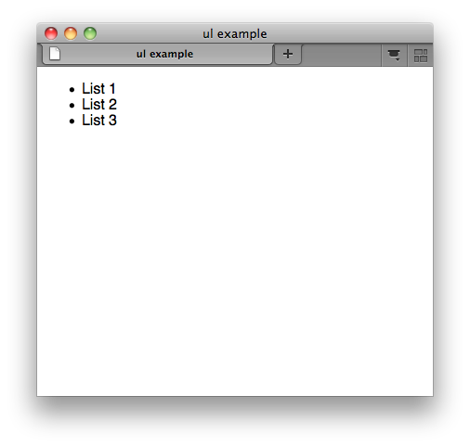](https://www.w3.org/community/webed/wiki/File:Tr_ul01.png)

**ordered list**

Ordered list is specified by **<ol>** and **<li>**.

* The items of the list are the li element child nodes of the ol element.
* The type attribute specifies the kind of marker to use in the list.

<ol type="lower-alpha">

<li>sample1</li>

<li>sample2</li>

<li>sample3</li>

</ol>

[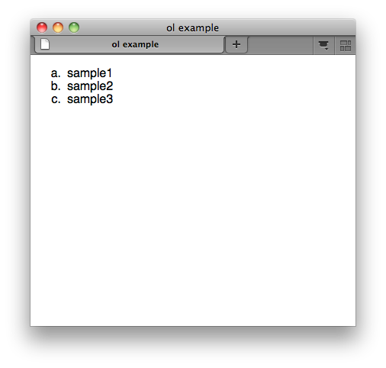](https://www.w3.org/community/webed/wiki/File:Tr_ol01.png)

**definition list**

Definition list is specified by **<dl>**, **<dt>** and **<dd>**.

<dl>

<dt>term1</dt>

<dd>definition1</dd>

<dt>term2</dt>

<dd>definition2</dd>

</dl>

[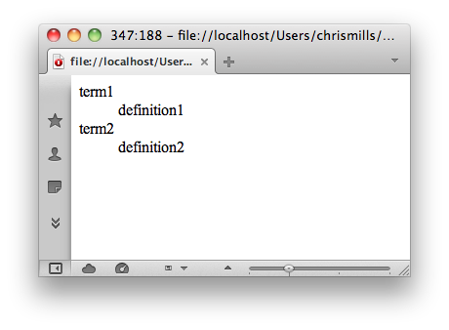](https://www.w3.org/community/webed/wiki/File:Tr_dl01.png)

challenge

**try it**

1. Create Web page's content that introduce your shop

[index.html]

<!doctype html>

<html lang="en">

<head>

<meta charset="utf-8">

<title>HOME | W3C cafe</title>

</head>

<body>

<h1>W3C cafe</h1>

<ul>

<li>menu</li>

<li>location</li>

<li>about us</li>

<li>recruit</li>

</ul>

<h2>new branch</h2>

<p>26 January 2011</p>

<p>

text text text text text text text text text text text text text text text text text text text text

text text text text text text text text text text text text text text text text text text text text

text text text text text text text text text text text text text text text text text text text text

text text text text text text text text text text text text text text text text text text text text

</p>

<h2>new menu</h2>

<p>26 January 2011</p>

<p>

text text text text text text text text text text text text text text text text text text text text

text text text text text text text text text text text text text text text text text text text text

text text text text text text text text text text text text text text text text text text text text

text text text text text text text text text text text text text text text text text text text text

</p>

<p>Copyright © 2011 W3C cafe</p>

</body>

</html>

2. Check your Web browsers.

[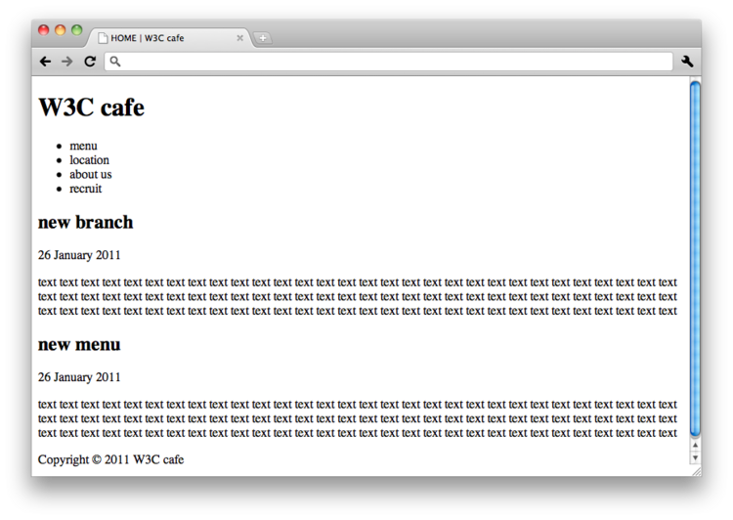](https://www.w3.org/community/webed/wiki/File:Basic.png)

Hyper Link

<body>

<ul>

<li><a href="faq1.html">What does W3C do?</a></li>

<li><a href="faq2.html">How is W3C funded?</a></li>

<li><a href="faq3.html">Is W3C sending me spam?</a></li>

</ul>

<p>Copyright © 2009 W3C ( <a href="http://www.csail.mit.edu/">MIT</a> ,

ERCIM , Keio) Usage policies apply.</p>

</body>

What is Hyper Links

Start of the World Wide Web is the ability to define links from one page to another, and to follow links at the click of a button. This is Hyperlink.

Hyper Links

Hyper Links are specified by **<a>**.  
Linked document is represented by **the href attribute**.

[syntax]

<a href="URL">Link label</a>

**try it**

Let's link to Google.

1. Enclose the link text between <a> and </a>.

<a>Go to Google</a>

2. Specifies the href attribute.

<a href="http://www.google.com/">Go to Google</a>

[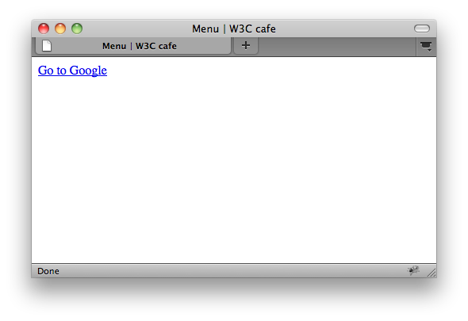](https://www.w3.org/community/webed/wiki/File:Tr_a01.png)

Relative paths or Absolute URL

**Relative path**

[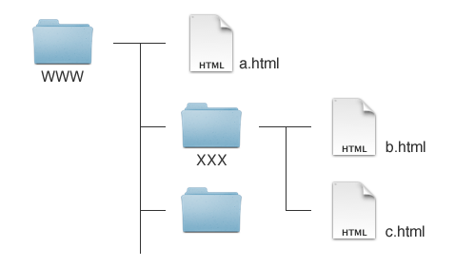](https://www.w3.org/community/webed/wiki/File:Path.png)

* **Linking to be in a same folder/directory**:

[Syntax]

<a href="**file.html**">Link label</a>

ex) [b.html-c.html]

<a href="**c.html**">Link label</a>

* **Linking to be in a parent folder/directory**:

[Syntax]

<a href="**../file.html**">Link label</a>

ex) [b.html-a.html]

<a href="**../a.html**">Link label</a>

* **Linking to be in a subdirectory**:

[Syntax]

<a href="**directory/file.html**">Link label</a>

ex) [a.html-b.html]

<a href="**XXX/b.html**">Link label</a>

**absolute URL**

* **Linking to a page on another Web site**.

<a href="**URL**">Link label</a>

Challenge

1. Links to other pages in our Web site.

[index.html]

<ul>

<li><a href="menu.html">menu</a></li>

<li><a href="location.html">location</a></li>

<li><a href="about.html">about us</a></li>

<li><a href="recruit.html">recruit</a></li>

</ul>

[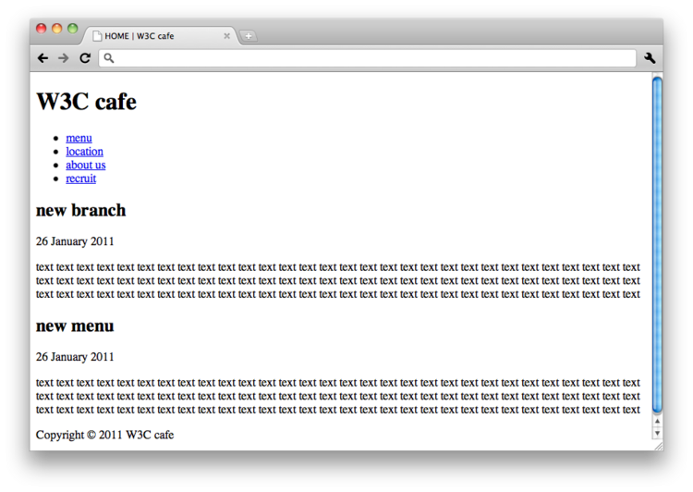](https://www.w3.org/community/webed/wiki/File:Hyperlink01.png)

Link options

In which window to open the link document

In which window to open the link document is specified by **the target attribute**.   
If you would like to open new window, you should use "_blank" for value of the target attribute.

<a href="<http://www.csail.mit.edu/>" **target="_blank"**>MIT</a>

* _blank: Open the new window.
* _self: Open the current one.
* _parent: Open the parent browsing context of the current one.
* _top: Open the most top-level browsing context of the current one.

Link that specifies position of Web page

Link that specifies position of Web page is specified by **the id attribute**.  
The id attribute specifies that its a element is a named hyperlink, with the name given by the value of this attribute.

1. Specifies the id attribute.

<h2 **id="top"**>Top</h2>

*note: The id attribute can be specified for any tag.*

2. The a element with the href attribute. Value of the href attribute is a named hyperlink that you would like to link.

<a **href="#top"**>Go back top</a>

**Challenge**

1. Specifies the name linked anchor by the id attribute.

[menu.html]

<h2 **id="food"**>Food</h2>

<h2 **id="drink"**>Drink</h2>

2. Specifies the link text by <a>.

[menu.html]

<p><a **href="#food"**>Food</a> | <a **href="#drink"**>Drink</a>

[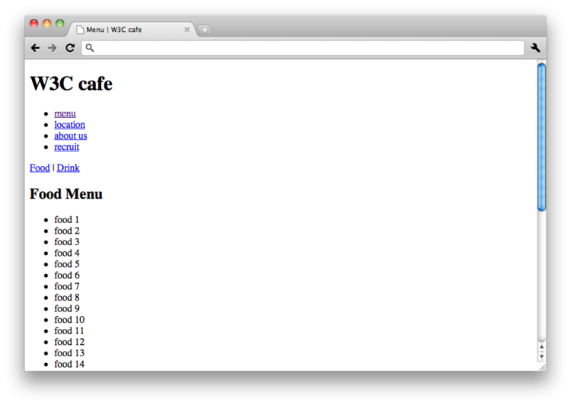](https://www.w3.org/community/webed/wiki/File:Hyperlink02.png)

HTML Images

<body>

<h1><img src="images/logo.png" alt="W3C" width="90" height="53"></h1>

</body>

Image

Images are specified by **<img>**.

* The img element can omit end element. This is because It is empty element.
* The image given by the src attribute is the embedded content.  
  SRC stands for **source**.

[syntax]

<img src="URL">

* The images are often save on images folder.

<img **src="images/logo.png"**>

Alternative text

You can specify an alternative text for an image.  
The value of the alt attribute give an alternative text for an image.

* **The intent is that replacing every image with the text of its alt attribute not change the meaning of the page**.

<img src="images/logo.png" **alt="W3C"**>

*Note: One way to think of alternative text is to think about how you would read the page containing the image to someone over the phone, without mentioning that there is an image present. Whatever you say instead of the image is typically a good start for writing the alternative text.*

Image size

Images size are specified by the width attribute and the height attribute.

* The width and height aren't strictly necessary but help to speed the display of your Web page.

<img src="images/logo.png" alt="W3C" **width="90" height="53"**>

Challenge

**try it**

1. Let's embed the logo image.

[index.html]

<h1>**<img src="images/logo.png" alt="W3C cafe" width="249" height="107">**</h1>

[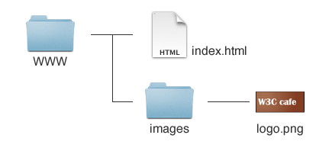](https://www.w3.org/community/webed/wiki/File:Images.png)

2. Check your Web browsers.

[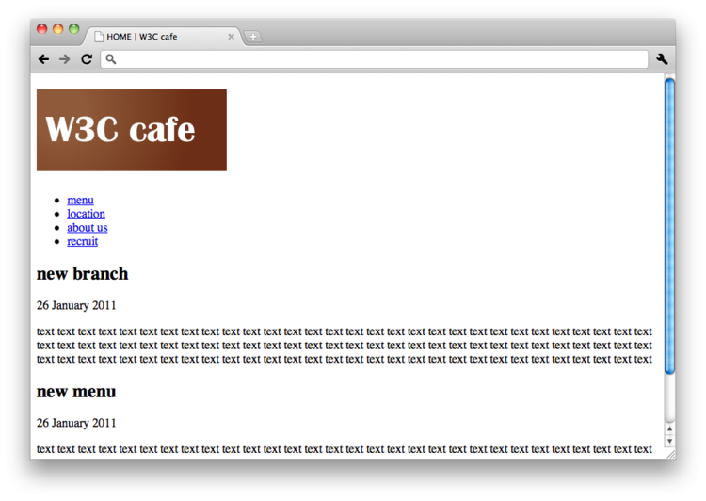](https://www.w3.org/community/webed/wiki/File:Image_chall01.png)